WP2 Trajectory Processing

TOM Robotics developed a data processing pipeline that enabled the processing of camera recordings from the Austrian and Chinese urban locations. The developed object detection and tracking pipeline works with multiple cameras and various camera orientations, and was fine-tuned to match the characteristics of Austrian and Chinese video recordings. During the completion of a diploma thesis, a robust object-level multi-sensor fusion algorithm was developed and introduced to enable tracking across multiple sensors. The data is transformed into UTM (Austrian) and local UTM-like (China) coordinate systems for further processing. In Austria, we could utilize ground truth data observed by the measurement vehicle of FTG to validate the processing pipeline and further refine it, see Fig. 1. The system developed for the Austrian urban sections was transferred and adapted to meet the requirements of Chinese urban video recordings, including fine-tuning to local data in China and processing of the video material in accordance with data protection regulations.

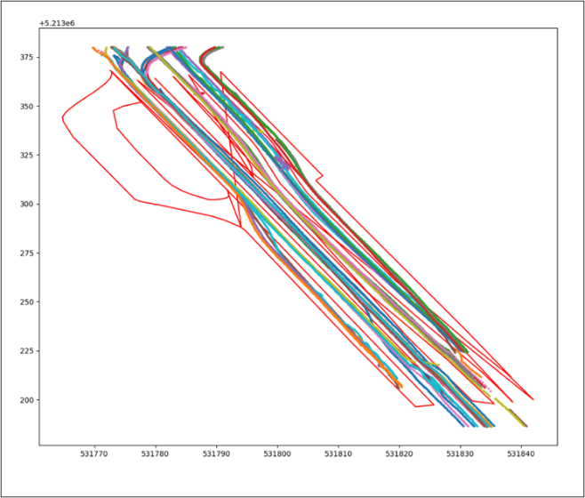
Figure 1: 50 sampled fused trajectories from the measurements at Graz central station

Description of the Austrian urban location

In Austria, Graz Central Station was selected as a suitable candidate for the analytics conducted by ISV, as well as for producing high-quality recordings to extract the trajectories. The location of Graz Central Station was selected due to the complex traffic scenarios, high traffic density, and the high number of lane changes expected, given the layout of the streets in the chosen area of interest. We mounted a total of four 4K IP Cameras in two different locations, filming the Bahnhofgürtel between Kepler Straße and Annenstraße, see Fig. 2.

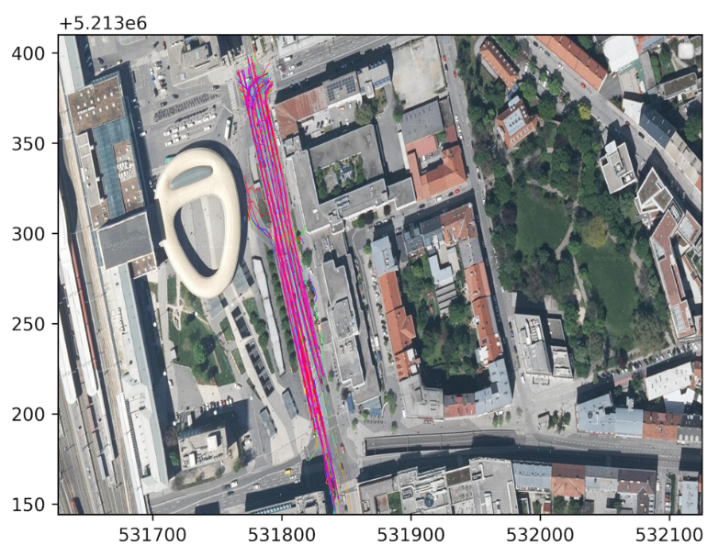
Figure 2: Sample trajectories plotted against an orthographic image of the selected area at Graz Central station [Source of orthographic image: GIS Steiermark]

A measurement campaign to get videos for the Austrian urban location was successfully executed. Four 4K IP Cameras were mounted in 2 locations near the Graz Central Station. These recordings formed the basis for the trajectory database, as the trajectory processing pipeline processed these videos to obtain the trajectories of individual vehicles.
To validate the results of the perception and tracking pipeline, a reference measurement was made, using the Research Vehicle from FTG, to produce a Ground Truth Measurement of the FTG Vehicle location based on RTK corrected GNSS measurements and of surrounding vehicles using a lidar sensor, see Figure 3.

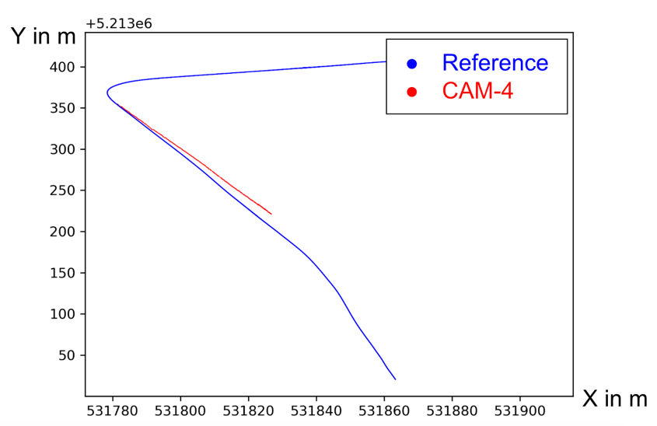
Figure 3: Comparison between trajectory and reference data

Austria, motorway location:
The Austrian motorway location, selected in the first year, was measured by the service provider ALP.Lab, using synergies of the parallel FFG project Central System. Since the first measurements were unsatisfactory, the equipment was replaced, and a second measurement was taken. The data was handed over and checked for quality. It turned out that the off-ramp data were of acceptable quality and were used for further evaluation in WP3, as shown in Fig. 4. On-ramp data was not of sufficient quality for processing trajectories.
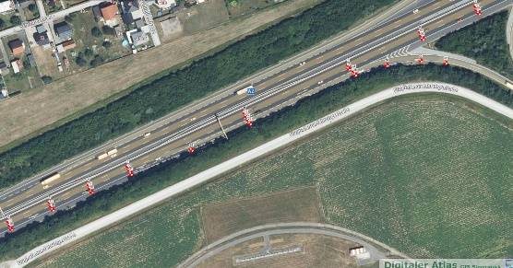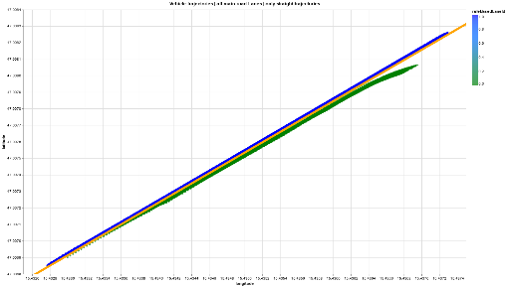
Figure 4: Austrian motorway location and processed lane trajectories

Zhejiang Province, Urban Location
In Zhejiang Province, China, after evaluating and validating several samples of data from multiple sites with different observation angles, the location Yongan Street, Deqing City, Zhejiang was selected for urban data collection, see Figures 5.
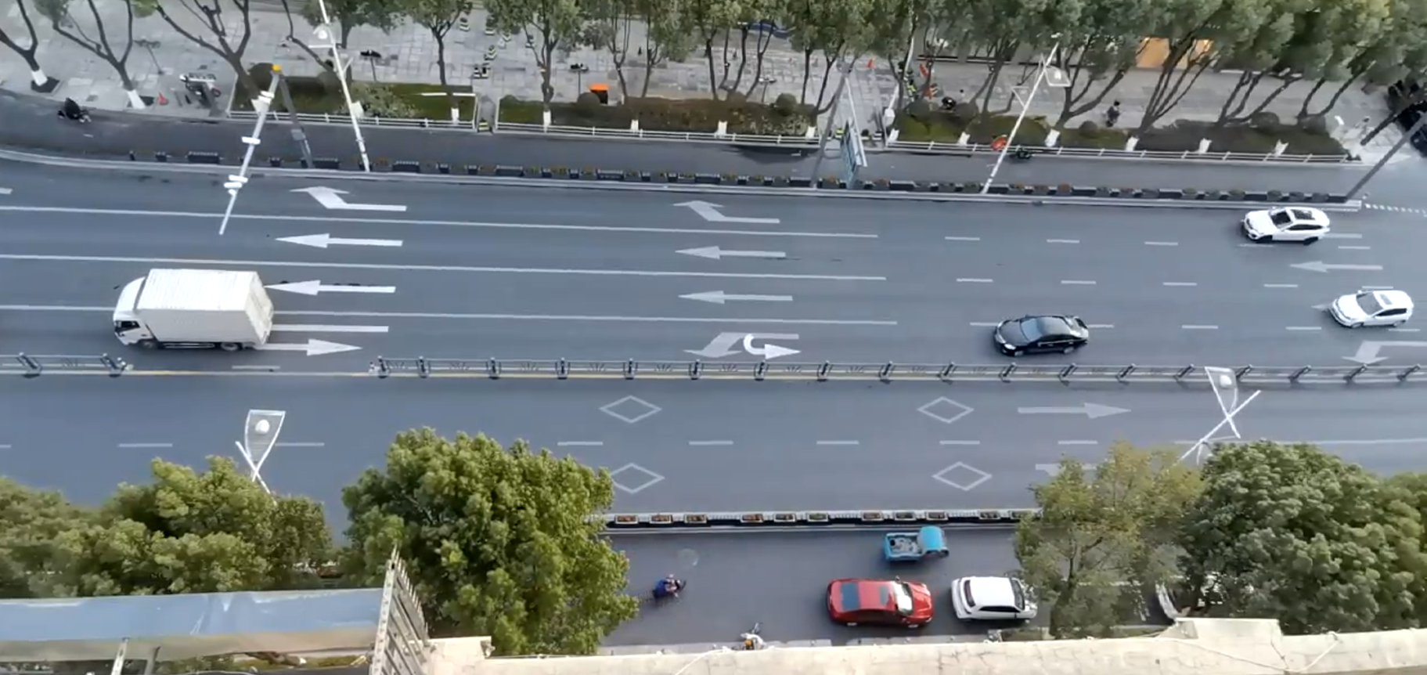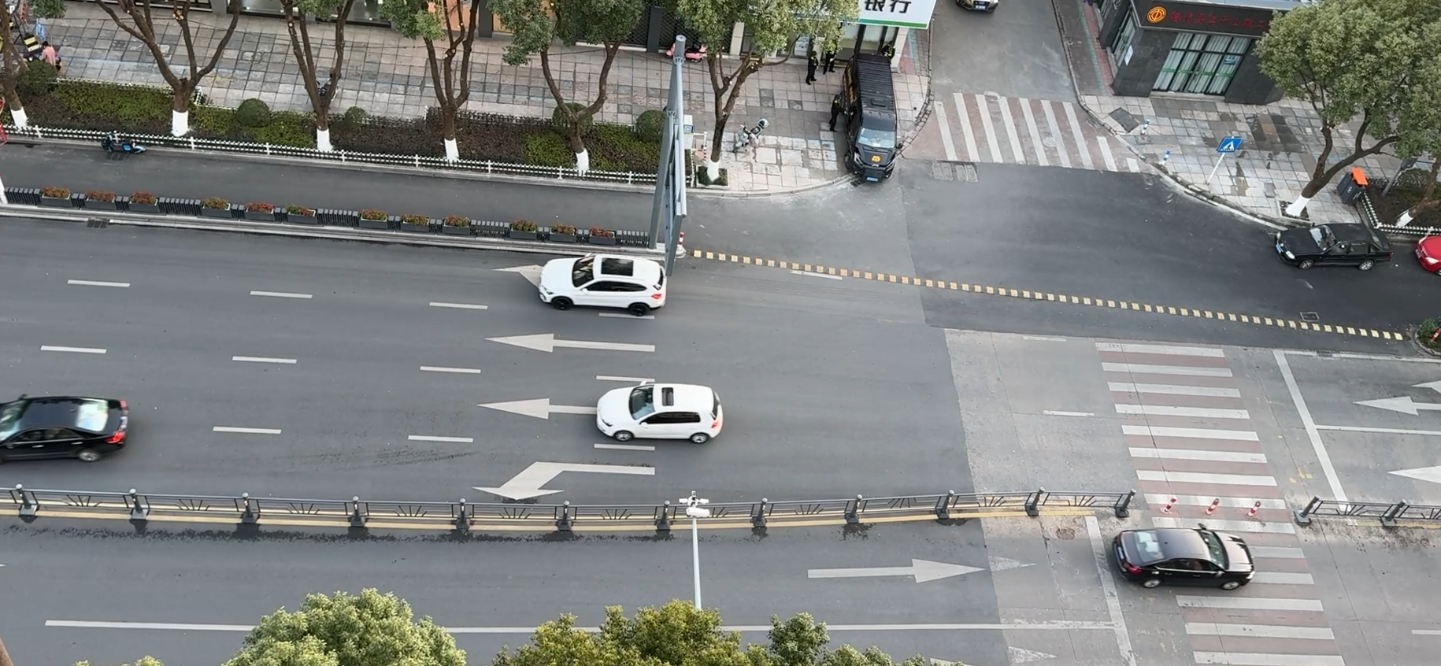
Figure 5: urban data collection site 2-1 Yongan Street, Deqing City, Zhejiang
Videos of the selected urban section in China were recorded and processed using the TRIDENT trajectory processing pipeline on Chinese workstations, in accordance with data privacy regulations, see Fig. 6 through 8.
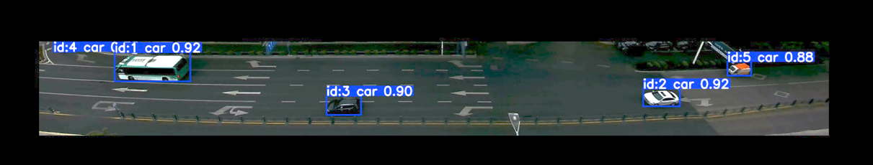Figure 6: urban data collection Yongan Street, Deqing City, Zhejiang, Sample of Video with object detection results
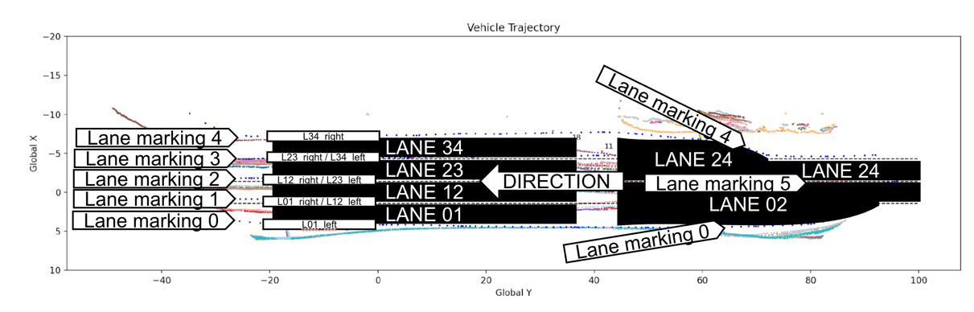Figure 7: Lane Markings and Lane IDs for the Chinese Urban dataset in Yongan Street, Deqing City, Zhejiang
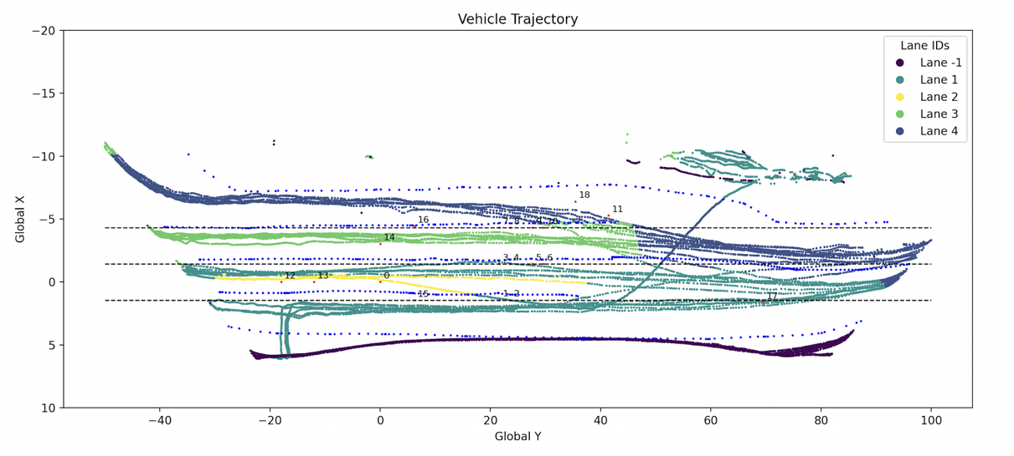 Figure 8: Vehicle Trajectory data with corresponding lane ID (color coded)
Zhejiang Province, Motorway Location:
Two high-speed observation data samples from different locations have been obtained as observation sites and were available for further trajectory processing and validation, see Figures 7. However, due to the security and qualification restriction policies of the Chinese Government, the address locations, coordinates, and observation camera parameters of the data observations were not available.
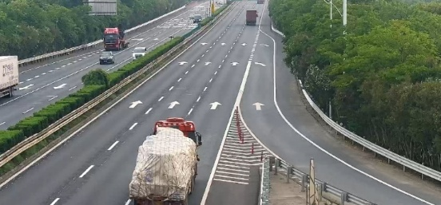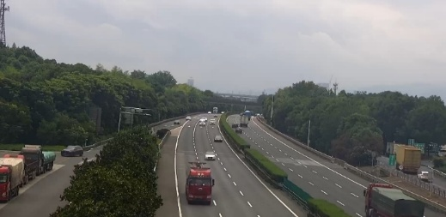
Figure 7: motorway data collection site 1 and 2
Due to these restrictions, we were not able to process the recorded videos for the Chinese highway sections. We therefore decided to use publicly available datasets, see WP3, for the project and focused our efforts on improving the urban datasets.

